Description:
In the GYXTW cable, single-mode/multimode fibers are positioned in the loose tube, which is made of high modulus plastic materials and filled with filling compound. PSP is longitudinally applied around the loose tube, and water-blocking materials are distributed into interstices between them to guarantee the compactness and longitudinal water-blocking performance. Two parallel steel wires are placed at both sides of the cable core while PE sheath is extruded over it.

Application : Aerial/ Duct
Main Feature:
1.Excellent mechanical and temperature performance guaranteed by the accurate excess fiber length.
2. Critical protection to fibers, based on the excellent hydrolysis resistance.
3. Excellent crush resistance and flexibility.
4. PSP enhances the cable crush-resistance, impact-resistance and moisture-proof.
5. Two parallel steel wires ensure tensile strength.
6. Excellent ultraviolet prevention with PE sheath，small diameter, light weight and installation friendliness.
Temperature Rage:
Operating :-40℃ to +70℃
Storage :-40℃ to +70℃
Standards:
Comply with standard YD/T 769-2010

Fiber & Loose tube color code

No. | Color | No. | Color | No. | Color | No. | Color
1 | Blue | 4 | Brown | 7 | Red | 10 | Purple
2 | Orange | 5 | Grey | 8 | Black | 11 | Pink
3 | Green | 6 | White | 9 | Yellow | 12 | Aqua

Fiber count | Structure | Fibers per tube | Loose tube diameter  (mm) | CSM diameter/pad diameter  (mm) | Nominal Thickness of outer jacket  (mm) | Cable diameter/  Height  (mm) | Cable weight  (kg/km)
2 | 1 | 2 | 1.7±0.1 | 1.0/1.0 | 1.6 | 8.0±0.2 | 57
4 | 1 | 4 | 1.85±0.1 | 1.0/1.0 | 1.6 | 8.0±0.2 | 58
6 | 1 | 6 | 1.9±0.1 | 1.0/1.0 | 1.6 | 8.0±0.2 | 58
8 | 1 | 8 | 2.0±0.1 | 1.0/1.0 | 1.6 | 8.0±0.2 | 60
12 | 1 | 12 | 2.2±0.1 | 1.0/1.0 | 1.6 | 8.0±0.2 | 60

PACKAGE
Material of the drum shall be fumigation wood.
The disc length can be customized according to customer requirements

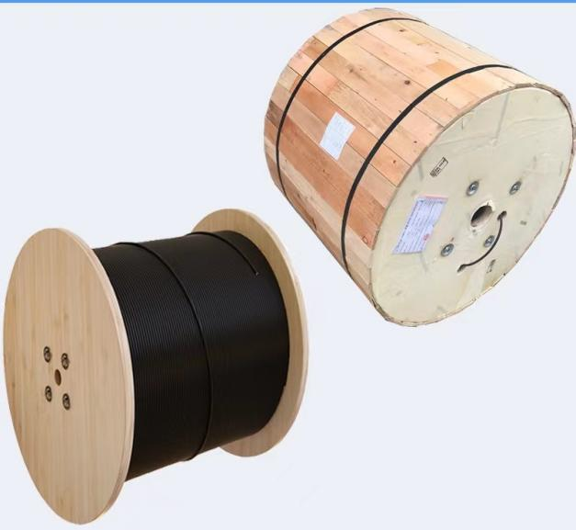
MARK
White color Ink jet printing, Cable Mark: Brand, Cable type, Fiber type and counts, Year of manufacture and Length marking.

